FORNAX™ ePlanCheck Rule
Rule Information
Rule ID | WTR 6.5.7
Rule Name | Hot and Cold Water in Mixing Valves, Pipes and Water Fittings
Chapter | PART 2 Distribution
Section | 2.5 Hot water supply systems
Handbook | Code of practice for water services  Incorporating amendment No.1 and No.2

Rule Description
2.5 Hot water supply systems

2.5.7 No mixing valves, pipes or other water fittings in which hot water and cold water are mixed shall be so
connected as to mix either:
(a) water supplied from a hot water heater connected directly to a service pipe with cold water not
supplied directly from a service pipe; or
(b) water supplied from a hot water heater not connected directly to a service pipe, with cold water supplied directly from a service pipe.

DESCRIPTION HERE
SECTION VIEW
Rule Interpretation
- This rule checks for the connection of the mixing valves, pipes, including water fittings; to where, the water supply for water heater should come directly from the service pipe including the cold water line.
- And inversely, this rule will also check if the connection of the mixing valves, pipes, including water fittings; to where, either the water supplying the water heater or the cold water line is connected via the distribution line.
- By definition, the "water-service" pipe line extends from the potable water source to the interior of a building. Inside the building the "water-service" pipe becomes a "water-distribution" pipe.
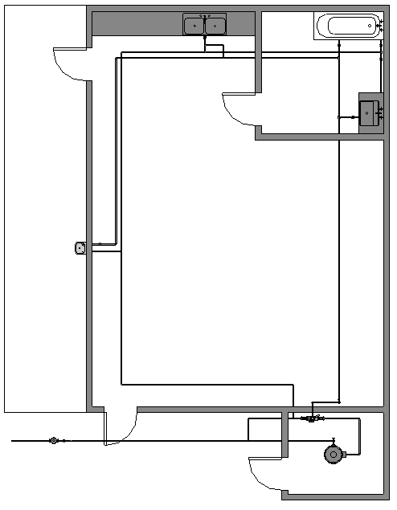

Hot water pipe

Hot water pipe
Water Distribution pipe (cold)

Mixing Valve

Water Service pipes

Water Heater
Sample Water Supply Layout

FIGURE 01

Rule Scenario

Scenario 01 - Compliant
Requirement | The supply of water for cold water line and water heater shall be supplied directly from the service pipe.
Description | A mixing valve including its pipes and fittings is connected to a water heater to which its water source is connected to the service pipe; and its cold water supply is also connected to the service pipe.
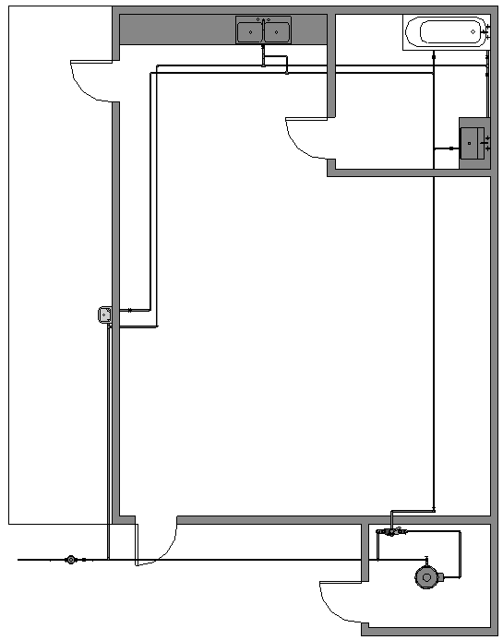

Hot water pipe

Hot water pipe
Water Distribution pipe (cold)

Water Service pipe
Mixing Valve

Water Heater

PLAN

FIGURE SCENARIO

Scenario 01 - Non-Compliant 01
Requirement | The supply of water for cold water line and water heater shall be supplied directly from the service pipe.
Description | The supply for hot water is connected directly to the service pipe but its cold water supply is not connected directly to the service pipe.
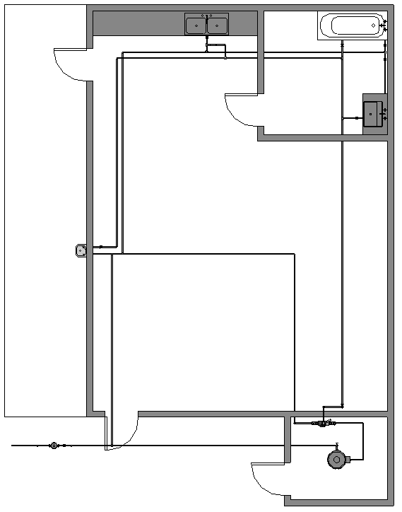

Hot water pipe
Water Distribution pipe (cold)
Hot water pipe

Water Service pipe

Water Heater

PLAN

FIGURE SCENARIO

Scenario 01 - Non-Compliant 02
Requirement | The supply of water for cold water line and water heater shall be supplied directly from the service pipe.
Description | The water supply for both Hot and Cold water is not connected from the Service pipe.
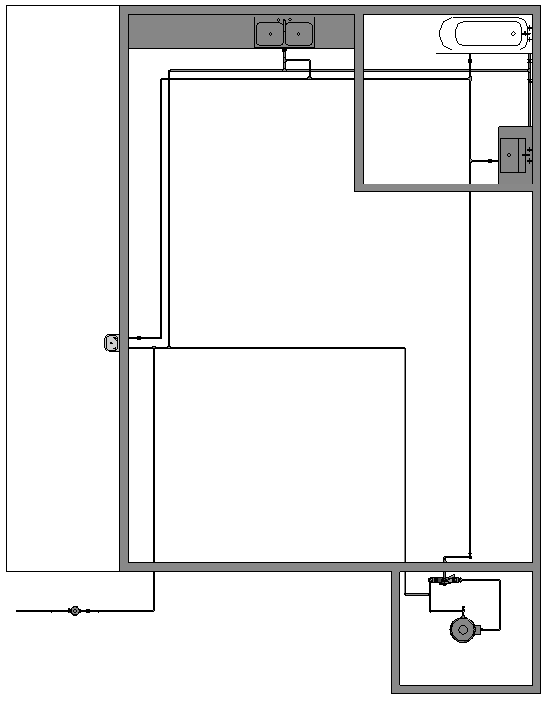

Hot water pipe
Water Distribution pipe (cold)

Hot water pipe

Mixing Valve

Water Heater
Water Service Pipe

PLAN

FIGURE SCENARIO

Request For Information
- The Rule description stated in 24_Appendix 2_COP rules.pdf for WTR 6.5.7 does not exist in IBS_PUB-CP 48-2005+Amd 1&2.pdf
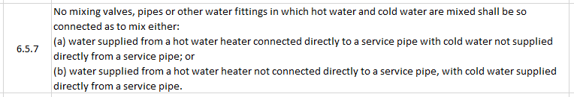

- We believe that this Rule actually directs to WTR 2.5.7 in IBS_PUB-CP 48-2005+Amd 1&2.pdf. Is this correct?
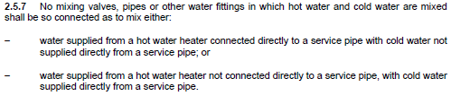

Model PreCheck

Required Elements | Required Attributes
PipeSegment | IfcDescription contains “Cold Water”
PipeSegment | IfcDescription contains “Service Pipe”
IfcFlowTerminal | Name contains “Water Heater”, “Hot Water Cylinder”

Rule Parameters

System Type
Cold Water |  | 
Hot Water |  | 
 | Sanitary
 | Sewerage
Vent

Element Type 1
State | Type | Property | Operator | Value
Include | IfcFlowTerminal | Name | Contains | Water Heater
Include | IfcFlowTerminal | Name | Contains | Hot Water Cylinder
Include | PipeSegment | IfcDescription | Contains | Cold Water
Exclude |  | Any | Match | N.A.
 |  | Name | N.A. | <User defined>

Element Type 2
State | Type | Property | Operator | Value
Include | PipeSegment | IfcDescription | Contains | Service
Exclude |  | Any | Match | N.A.
 |  | Name | N.A. | <User defined>

Element Type 1 Condition

* Shall be connected to Element Type 2

Result Messages
- 6.5.7 Hot and Cold Water in Mixing Valves, Pipes and Water Fittings
  - Non-Compliant (TotalResultNumeric)
    - BuildingStorey (TotalResultPerFloorNumeric)
    - ElementType1Name is not connected to ElementType2Name
  - Compliant (TotalResultNumeric)
    - BuildingStorey (TotalResultPerFloorNumeric)
    - ElementType1Name is connected to ElementType2Name
  - Attention (TotalResultNumeric)
    - BuildingStorey (TotalResultPerFloorNumeric)
    - No Water Heater found.

Sample Result Messages
- 6.5.7 Hot and Cold Water in Mixing Valves, Pipes and Water Fittings
  - Non-compliant (2)
  - Level 1 (1)
- Water Heater 102 or Cold water Line 102.1 is not connected to Service pipe.
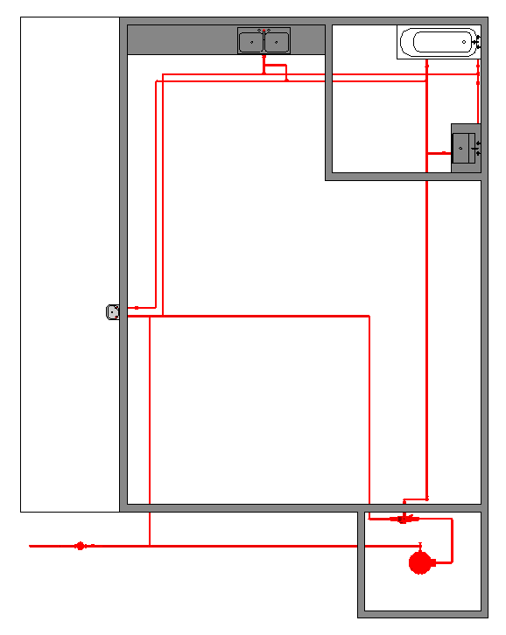

PLAN
    - Level 1 (1)
- Water Heater 102 or Cold water Line 102.1 is not connected to Service pipe.
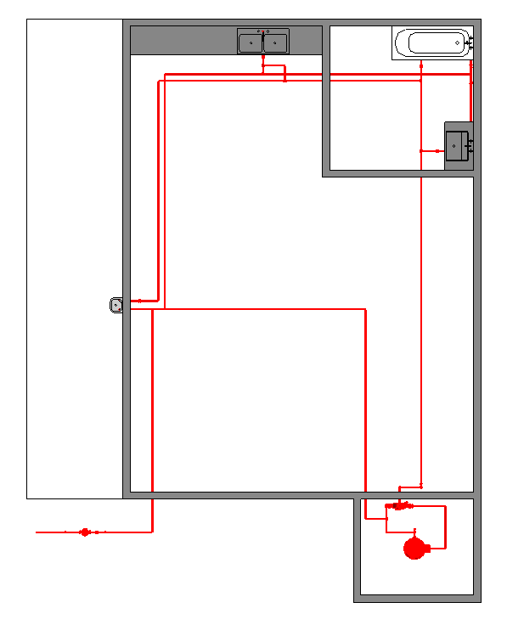

  - Compliant (1)
    - Level 1 (1)
PLAN
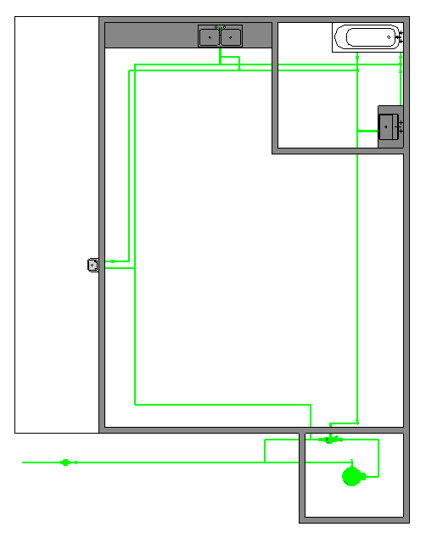
- Water Heater 102 and Cold water Line 102.1 is connected to Service pipe.

PLAN

Sample Result Model Views
- WTR 6.5.7 Hot and Cold Water in Mixing Valves, Pipes and Water Fittings
  - Non-Compliant
    - Plan view.
    - Highlight checked element/space.
    - All other elements are translucent except the checked element/space.
  - Compliant
    - Plan view.
    - Highlight checked element/space.
    - All other elements are translucent except the checked element/space.

Testing Scenario Notes
- Scenario 01 – Complaint
- Level 01
- A mixing valve including its pipes and fittings is connected to a water heater to which its water source is connected to the service pipe; and its cold water supply is also connected to the service pipe.

- Scenario 01 – Non-Complaint 1
- Level 01
- The water supply for hot water is connected directly to the service pipe but its cold water supply does not, but rather connected to the distribution pipe.

- Scenario 01 – Non-Complaint 2
- Level 01
- The water supply for both Hot and Cold water is not connected from the Service pipe.

Model:
WTR 6.5.7 Scenario 01 Complaint.ifc
WTR 6.5.7 Scenario 01 Non-Complaint 1.ifc
WTR 6.5.7 Scenario 01 Non-Complaint 2.ifc

Modelling Guideline
- Specify IfcDescription containing “Hot Water” for relevant PipeSegment.
- Specify IfcDescription containing “Cold Water” for relevant PipeSegment.
- Specify IfcFlowTerminal containing “Water Heater”, “Hot Water Cylinder” for relevant IfcFlowTerminal.

Specification Log
RA | Mark Anthony Enano
Last edit date | 30 October 2018
ePC version
Updates | - V1

